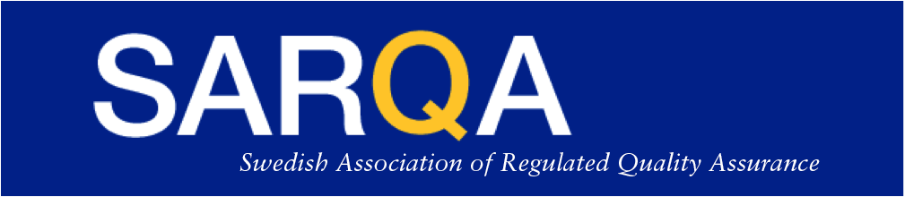

SARQA/DKG Conference - November 15th 2018 – Registration Form

“Quality Complexity – Navigating International Challenges”
The 8th Scandinavian Quality Assurance Conference

The language of this conference is English and the conference is open outside membership

Conference fee is 1 900 SEK / 1 400 DKK

Name | []
Company | []
Email | []
Telephone | []

All information above is mandatory - Check the below boxes that apply!
Please proceed to payment at your earliest convenience since registration will not be confirmed until full payment been received. Last date of payment is November 2nd!

I am a SARQA member and will attend the conference
I am a DKG member and will attend the conference
I’m not yet a member, but wish to become – Please contact me for membership!
I will stay for the Post-Conference drinks, finger-food and Networking Event

Allergy information | []

The conference administration will be organised by SARQA. Please send the “Registration Form” to – Lars-Eric Ellow at larsa@key2c.com
Payment to: SARQA’s bankgiro 5226-4553,
SARQA Swish 123 318 0015,
IBAN: SE4950000000053541011785
BIC/SWIFT-kod: ESSESESS
Bank address: SEB, Storgatan 11, SE-151 24 Södertälje, Sweden

Chose most convenient payment method and don’t forget to mark the payment with your name!

Refund Policy: Registration is binding, with free cancellation up to September 7th. After September 7th no refund is possible, but at any time prior to November 9th you can nominate a substitute. If so please notify larsa@key2c.com with contact information of the substitute.
Handling personal data: For SARQA/DKG members, see corresponding web sites for integrity policy. For non-members we can only accept registration if SARQA/DKG integrity policy is accepted and by so your consent is given by filling out and filing this registration form. By submitting this form the above conditions are accepted and we have your consent.

