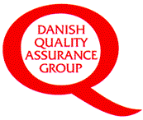
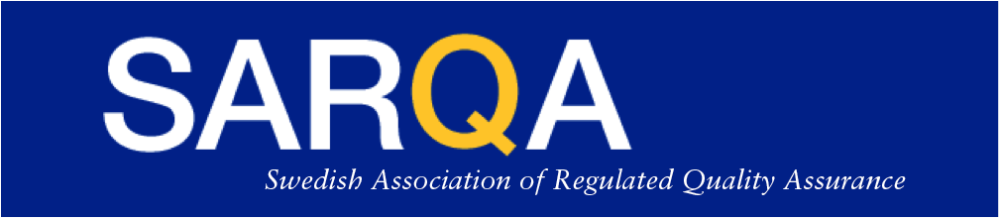

SARQA/DKG Conference – October 5th 2021 – Registration Form
“Ensuring Quality, it all comes down to Collaborations”
The 9th Scandinavian Quality Assurance Conference

The language of this conference is English, and the conference is open outside membership.

Conference fee is 1 400 DKK / 1 900 SEK

Name | []
Company | []
Email | []
Telephone | []

All information above is mandatory - Check the below boxes that apply!
Please proceed to payment at your earliest convenience since registration will not be confirmed until full payment has been received. Last date of payment is September 23rd, 2021!

I am a SARQA member
I am a DKG member
I’m not a member of SARQA/DKG
I will stay for the post-Conference drinks, finger-food, and Networking Event.

Allergy information | []

The conference administration will be organised by DKG/SARQA.

For registration with DKG (payment DKK):
Please send the “Registration Form” to DKG at dkg@dkgqa.com
Payment to: Danske Bank: 7506678 Reg. 1551 (add you name as payment reference)
For registration with SARQA (payment SEK):
Please send the “Registration Form” to SARQA at styrelse@sarqa.com
Payment to: SARQA’s bankgiro 5226-4553,
SARQA Swish 123 318 0015,
IBAN: SE4950000000053541011785
BIC/SWIFT-kod: ESSESESS
Bank address: SEB, Storgatan 11, SE-151 24 Södertälje, Sweden
Chose most convenient payment method and do not forget to mark the payment with your name!
- Refund Policy: Registration is normally binding upon receival of the registration, but due to the pandemic situation we will practice a more liberal policy and pay close attention to travel and meeting restrictions.
- Handling personal data: For SARQA/DKG members, see corresponding web sites for integrity policy. For non-members we can only accept registration if SARQA/DKG integrity policy is accepted and by so your consent is given by filling out and filing this registration form. By submitting this form, the above conditions are accepted, and we have your consent.

